**Assignment No. 01**

**CS504**

**ID: Bc230200839**

**Name: Zain Ul Abdeen**

**Question#1:**

In a use case diagram, two types of relationships can exist between use cases:

1. **Extend** relationship between two use cases
2. **Include** (uses) relationship between two use cases

Identify and label the relationships as either "extend" or "include" for the connections numbered 1 to 5 in the figure below

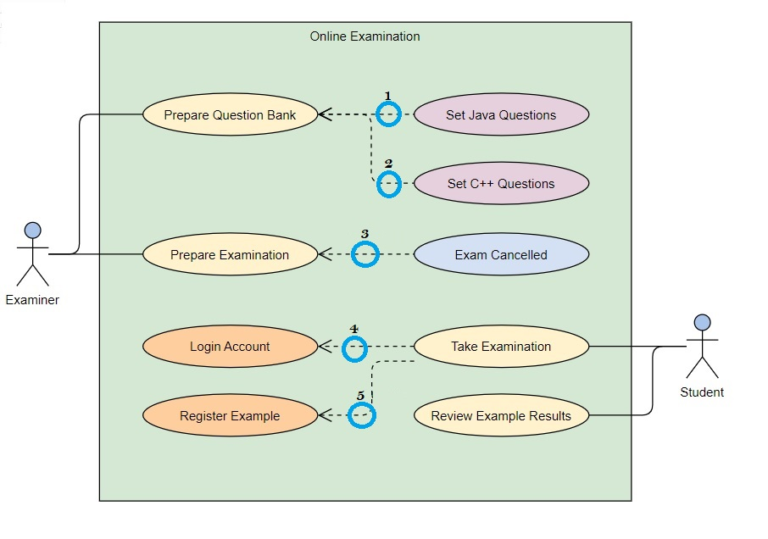

**Answer:**

1. Include
2. Include
3. Extend
4. Include
5. Include

**Question#2:**

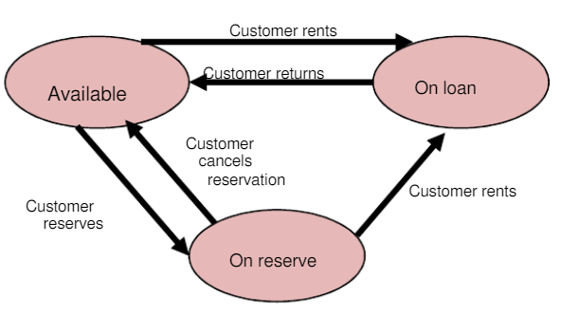

**Answer :**

|  |  |  |
| --- | --- | --- |
| **Current State** | **Event** | **Next State** |
| Available | Rent movie | On Loan |
| Reserved | Rent movie | On Loan |
| On Loan | Return movie | Available |
| Reserved | Cancel reservation | Available |
| Available | Reserve movie | On Reserve |